

**Learning Guide:**

**The White House**



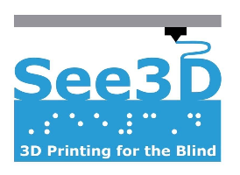

# **Overview:**



The White House is located in Washington D.C and is the official building where the President resides and works. In addition to the President, the White House staff – including the chief of staff, advisors and press secretary – have offices and work in the White House.

Model designed by MakerBot from <https://www.thingiverse.com/thing:461235>

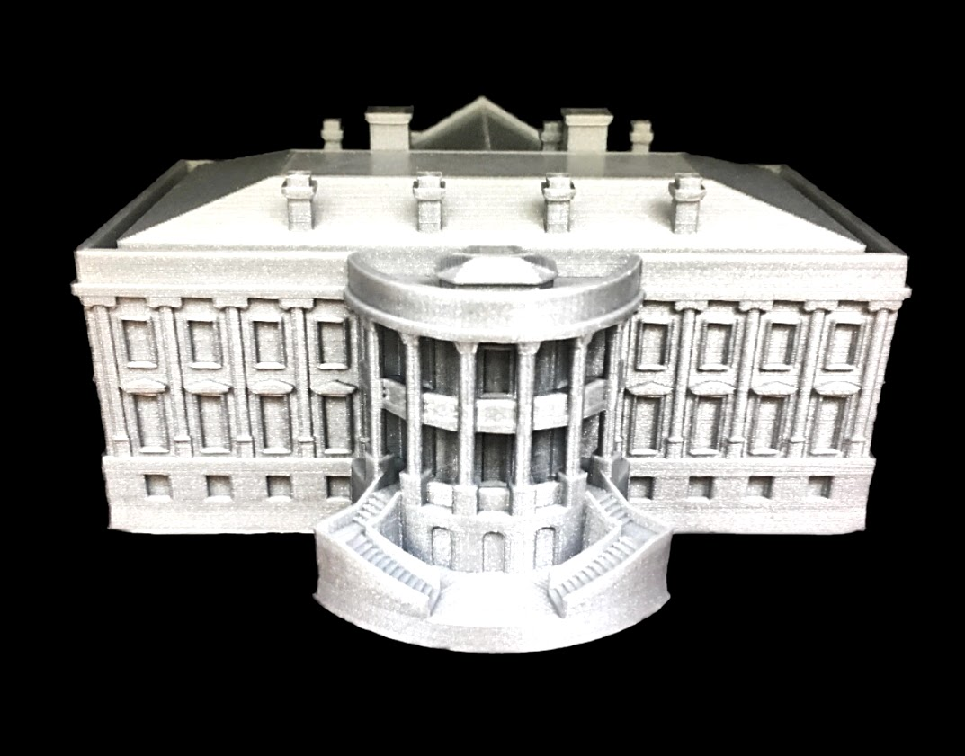

The image above depicts the 3D model of the White House North Lawn

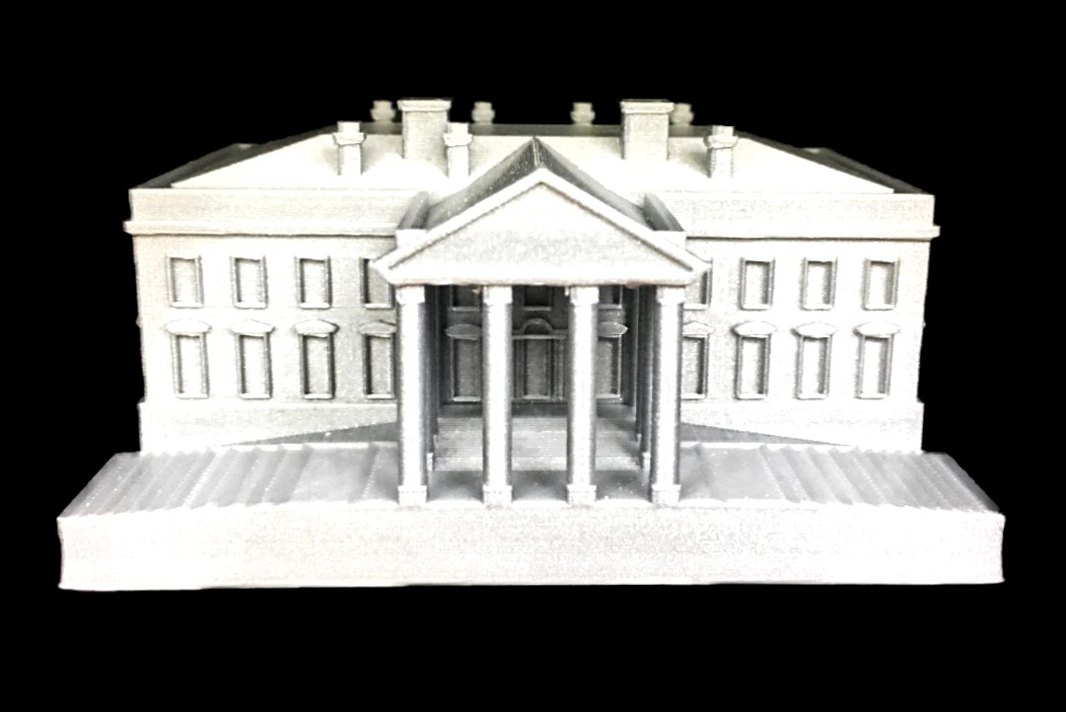

The image above depicts the 3D model of the White House South Lawn

# **Walkthrough:**



1. Place the flat side of the model on a flat surface. Feel for a triangular prism that has a point at the top and has four cylindrical pillars underneath. The side of the model with this triangular prism should be facing toward you. The base of the model will feel smooth when facing toward you. This is the front side of the White House, which is also known as the North Lawn.
2. Feel for the four pillars in the front of the model once again. Like many other buildings and memorials throughout D.C, the White House pillars in front of the building. They do not hold any symbolic significance, but they contribute to the elegant style of the White House.
3. Feel the model behind the pillars. You will feel many rectangles raised on the model, and these rectangles are the windows that surround the White House. In total, there are 147 windows on the White House.

Feel the top of the model behind the triangular prism you felt earlier. You should feel four rectangular prisms protruding out of the top of the model. There are two large and two small rectangular columns located on the roof of the White House. These columns are not significant since they are solely there for aesthetic purposes.

1. Flip the model so that the side opposite of the triangular prism top is facing you. This side should feel round in the front of the model, and the base has stairs instead of feeling flat. The model is now situated as if you were in the South Lawn of the White House. Like the front side of the model, this side of the model has multiple pillars in front of the building.
2. A semi circular shape is above the pillars and is a balcony for the president, other members of the White House and guests. Above the balcony, you will feel four raised rectangular prisms that are the same size. These are not very significant as they are just there for stylistic purposes.
3. Below the balcony and pillars, there are two staircases that lead to the lawn. When finding the staircases, feel for a series of raised lines.

Behind the pillars, there is the main body of the White House. You will feel many rectangular windows that are a part of the 132 rooms and 35 bathrooms of the White House.

1. The White House is a large building which is 168 feet (52 meters) long and 152 feet (46 meters) wide.

# **Citations:**



“The White House Building.” *The White House*, The United States Government, 2020, www.whitehouse.gov/about-the-white-house/the-white-house/.

“White House Dimensions.” *White House Historical Association*, 2020, [www.whitehousehistory.org/press-room-old/white-house-dimensions](http://www.whitehousehistory.org/press-room-old/white-house-dimensions).